Name: _____________________

Geometry: Chapter 5 Review
- Use the linear approximation method to estimate the length of the cross country course.
(4 cm = 1 mile)

- Find the area of the regular polygon

- Find the area of the regular polygon

- Find the area of a circle with the given dimensions
- Radius of 5in. b. diameter of 2cm.

- Find the area of the sector

- Find the circumference of a circle with the given dimensions
- Radius of 7mm b. Diameter of 2.5ft.

- Find the length of the indicated arc

- Find the measure of the central angle AOB

- Find the measure of the inscribed angle ABC
- Find the measure of the inscribed angle ABC

- Find the value of x, y, and z

- Find the measure of angle DCE

- Find the value of x and state the power of P

- Find the value of the variable.
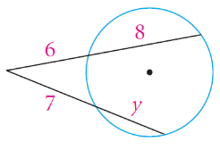
- Find the value of the variable.
