1. Solve for x:

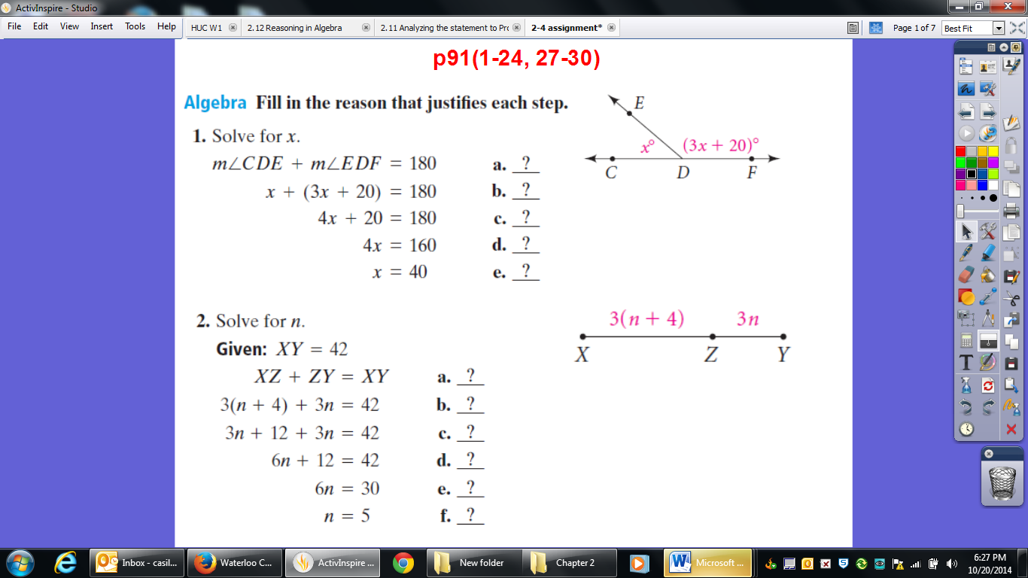

1. Solve for n:

XY = 42



1. Solve for x:

C is the midpoint of $\overline{AD}$

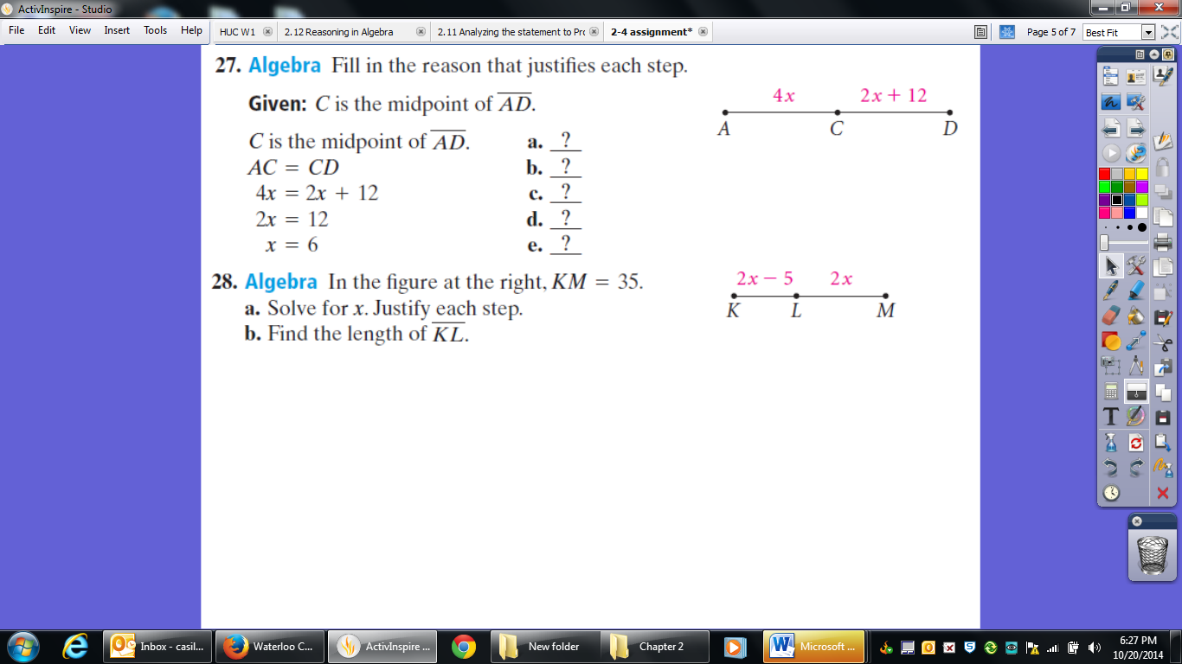

1. Solve for x:

KM = 35



1. Solve for x:

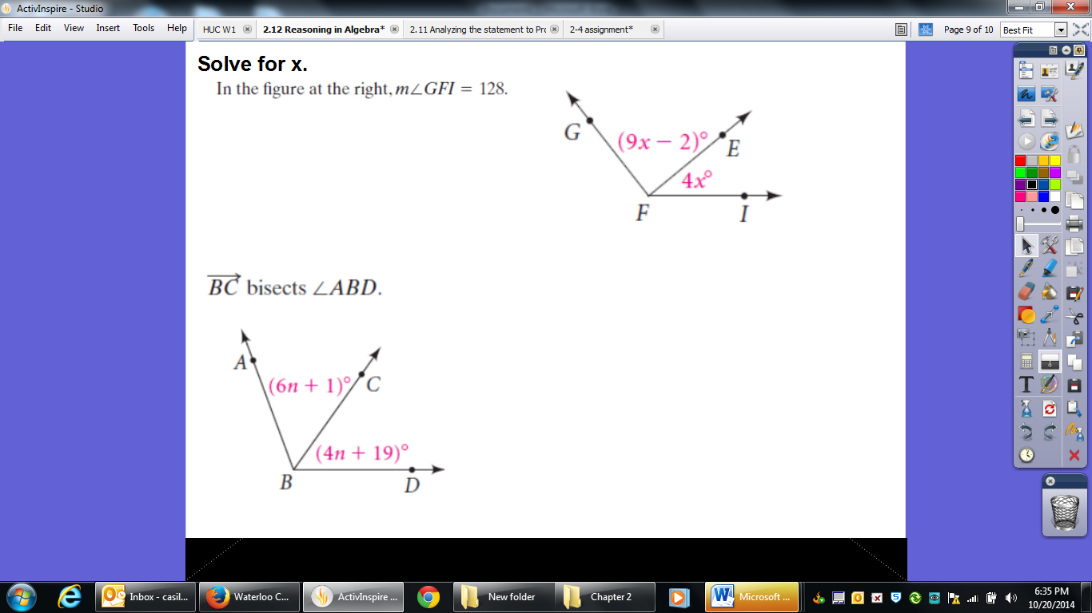

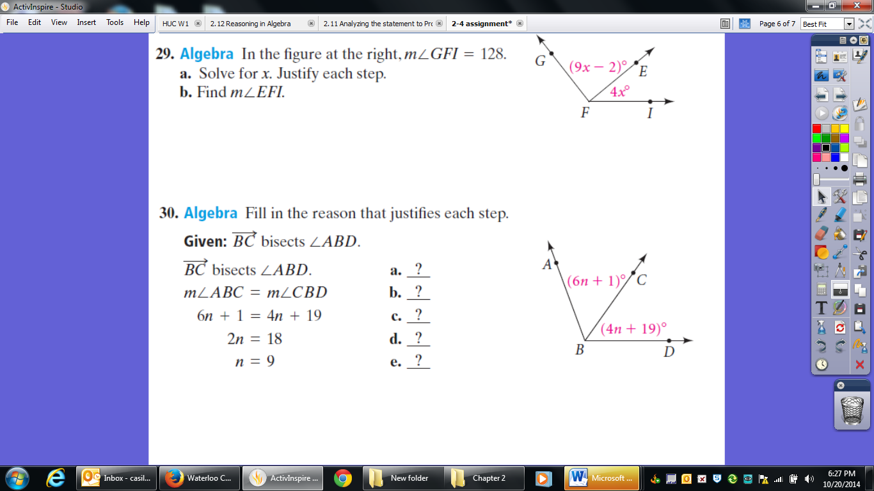

1. Solve for n:

